Lab #: Lab Title

ITI 1100 A/D - Digital Systems

Fall 2016

School of Electrical Engineering and Computer Science

University of Ottawa

Course Coordinator: Dr. Ahmed Karmouch

Teaching Assistants: TA 1 Name

TA 2 Name

Group #

Student Name and number #

Student Name and number #

Experiment Date:

Submission Date:
Objectives (2 marks*)

- Use point form with bullets

- State main objectives and sub objectives

- State laws/theorems verified if any

Equipment & Components (2 marks*)

- List all main instruments, tools, software and other components used

- Include their model/type

- Quartus II Student Edition Software

- Altera UP-1 circuit board

- Wire strippers etc…

Circuit Diagrams (2 ~ 8 marks*)

Include screen-shots of schematic design diagrams which shows all gates and other components with pin names clearly

Clearly specify to which part or section the figure is belong to, by following same title/sub-title structure used in lab manual.

Clearly Name and number Circuit Diagrams

Example:

Part I – Combinational Logic Circuits Construction

One Chip Logic Circuit
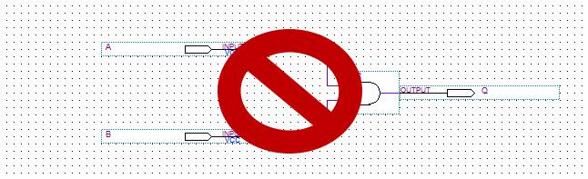

Sample

Only

Figure 1: Screen-shot of One-chip logic circuit diagram (Figure 6.1.1 of Lab Manual)**

- Mark assignments can deviate from above values for different labs. This is to let you know roughly how much weight you should put for each part of the report
- Results and diagrams shown in this model lab report are not accurate

Experimental Data and Data Processing (4 ~ 10 marks*)

Include Screen-shots of simulation outputs. If you only include screen-shots of input waveform diagrams without simulation output, marks will not be given

Tabulate observed experimental results

Perform calculations using observed/measured data to obtain comparable results if necessary.

i.e. some observed results might need further processing before comparing with theoretical results.

Specify to which part or section screen-shots, calculations and tables are belong to) by following same title/sub-title structure used in lab manual.

Present experimental data in the same order as the procedure

Example

Part I – Combinational Logic Circuits Construction

One Chip Logic Circuit
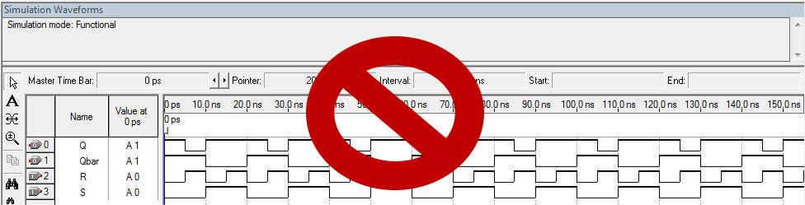

Sample

Only

Figure 2 : Simulation output waveform of one chip circuit**

Table 1 : Experimental data observed from MAX 7000 circuit board**

Input given from dip switches |  | Observed Output from
 |  | LED’s
A | B | Q
0 | Sample | 0
0 | 0 | 0
0 | ₁ Only | 0
1 | 0 | 0
1 | 1 | 1


- Mark assignments can deviate from above values for different labs. This is to let you know roughly how much weight you should put for each part of the report
- Results and diagrams shown in this model lab report are not accurate
Comparison of Theoretical Data and Experimental Data

(12 ~ 20 marks*)

Perform a side-by-side comparison of expected and experimental data in tables

Highlight important observations (if any), used in result analysis and comparison. Highlight major deviations of observed results (if any) from theoretical

Include calculations used for result analysis and comparison if necessary Explain briefly about compared and analyzed results

Example:

Part I – Combinational Logic Circuits Construction

One Chip Logic Circuit

Table 2 : Comparison of Theoretical and Experimental results for one chip logic circuit**
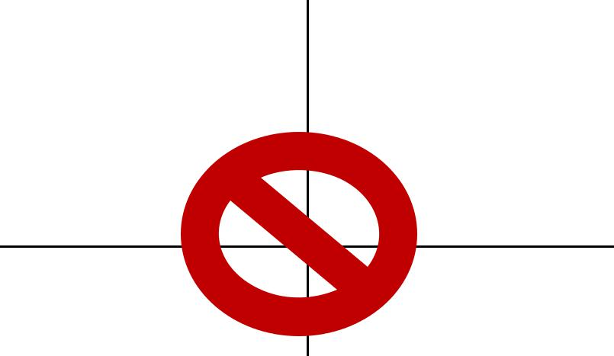
Inputs |  |  | Expected | Actual
 |  |  | Results | Results
A |  | B | Q | Q
0 |  | 0 | 0 | 0
0 |  | 1 | Sample 0 | 0
 |  |  | Only
1 |  | 0 | 0 | 0
1 |  | 1 | 1 | 1

The results observed experimentally for one chip circuit from MAX 7000 FGPA were identical to results obtained theoretically as expected.

Discussion & Conclusions (10 marks)

Discuss objectives and experiment methodology in brief

Discuss matching of expected and experimental data in general and state what laws have been verified, what sub-objectives have been met

Try to give logical explanation for major deviations of results (if any) and discuss problems you faced and solutions used to overcome them.

Appendix (Pre-Lab) (2 marks)

Attach clearly written pre-lab with correct order of pages

- Mark assignments can deviate from above values for different labs. This is to let you know roughly how much weight you should put for each part of the report
- Results and diagrams shown in this model lab report are not accurate

